TECHNICAL JUSTIFICATION DOCUMENT
React + Vite (vs) React + Next.js
Framework Selection for Dashboard UI - Internal Engineering Review

Prepared by | Jayasree G
Date | August 31, 2026
Purpose | Justify framework choice to manager - React + Vite over React + Next.js

1) ABOUT
It’s with building a dashboard UI that connects to FastAPI backend. As we initially suggested using React with Next.js. After researching other options, I recommend going with React + Vite instead, and this document explains the reasoning behind that decision for team alignment.
2) WHAT WE ARE BUILDING
A dashboard UI - a single-page application (SPA) where authenticated users can:
- View data and charts pulled from our FastAPI backend
- Interact with filters, tables, and controls
- Navigate between different dashboard views

This is an internal, authenticated tool - not a public-facing marketing site or e-commerce platform. That distinction is the foundation of every argument below.

3) ARCHITECTURE COMPARISON - VITE.JS VS NEXT.JS
The diagram below shows what the actual system architecture looks like under each option. With Vite, the frontend is a pure client that calls our existing FastAPI service. With Next.js, an additional server layer is added that our project does not need.
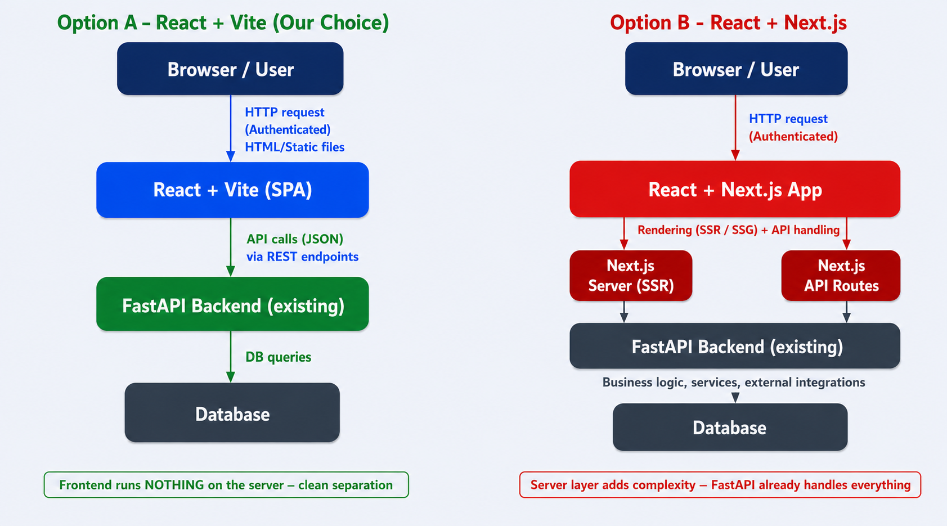
Figure - System architecture: React + Vite (left) vs React + Next.js (right)
Vite produces a plain static build (HTML + JS + CSS). It can be served from any CDN, S3 bucket - no Node.js server required at runtime.
]

4) NEXT.JS FEATURES - DO WE ACTUALLY NEED THEM?
Next.js is a powerful framework. Its value comes from server-side capabilities. Below is an honest assessment of each feature against our project's actual requirements.

Next.js Feature | What It Does | Need It?
Server-Side Rendering (SSR) | Renders pages on the server per request | No
Static Site Generation (SSG) | Pre-builds pages at deploy time | No
Built-in API Routes | Write backend endpoints inside Next.js | No
File-based Routing | Folders map to URL routes automatically | Not needed
Image Optimisation | CDN-level image resizing and delivery | No
Middleware / Edge Functions | Server-side auth and redirect logic | No

Every core feature Next.js adds beyond plain React exists to compensate for the absence of a dedicated backend - and we already have one (FastAPI).

5) WHY REACT + VITE IS THE RIGHT FIT
A. We Already Have a Backend
Our FastAPI service handles authentication, all business logic, and every API endpoint the UI will call. With Vite, the frontend is a pure client - it calls our APIs and renders the result. That is exactly the architecture we need, and it avoids doubling server concerns.

B. Dashboard UIs Are SPAs by Nature
A dashboard is not a blog or product page. Users log in once, the app loads, and navigation happens dynamically. There is no SEO requirement for an authenticated internal tool. React Router with Vite gives us clean, fast client-side navigation - exactly what a dashboard needs.

C. Simpler Learning Curve for a Backend Developer
As someone new to frontend, reducing cognitive load is critical for delivering quality work. Next.js introduces concepts on top of React that I would need to learn simultaneously: app/ vs pages/ router differences, 'use client' vs 'use server' directives, Server Components vs Client Components, hydration errors, and Next.js-specific data fetching patterns. With Vite, I only need to learn React. The learning curve is a straight line, not a staircase.

D. Dramatically Faster Development Feedback Loop
Vite uses native ES modules and skips full app pre-bundling during development. This makes the iteration cycle dramatically faster - important when learning a new domain.

E. No Accidental Complexity
Next.js comes with enforced opinions: a prescribed folder structure (app/, public/, api/), middleware hooks that can interfere if misconfigured, and deployment assumptions tied to Vercel for full feature parity. Vite has none of these constraints - the config is a single vite.config.js file, folder structure is flexible, and production output is a plain static build that deploys anywhere: S3, Nginx, or any CDN.
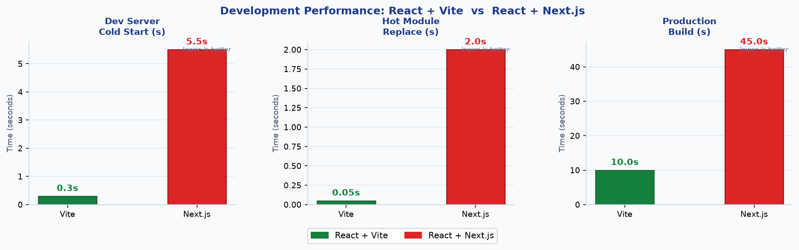
Figure - Dev speed comparison: cold start, HMR, and production build times
For a developer who is working with frontend and will be iterating on the UI frequently, fast feedback is a practical productivity multiplier - not just a vanity metric.

6) DECISION FLOWCHART
The flowchart below walks through the key questions that determine the right framework. Our project satisfies every condition that points toward Vite.
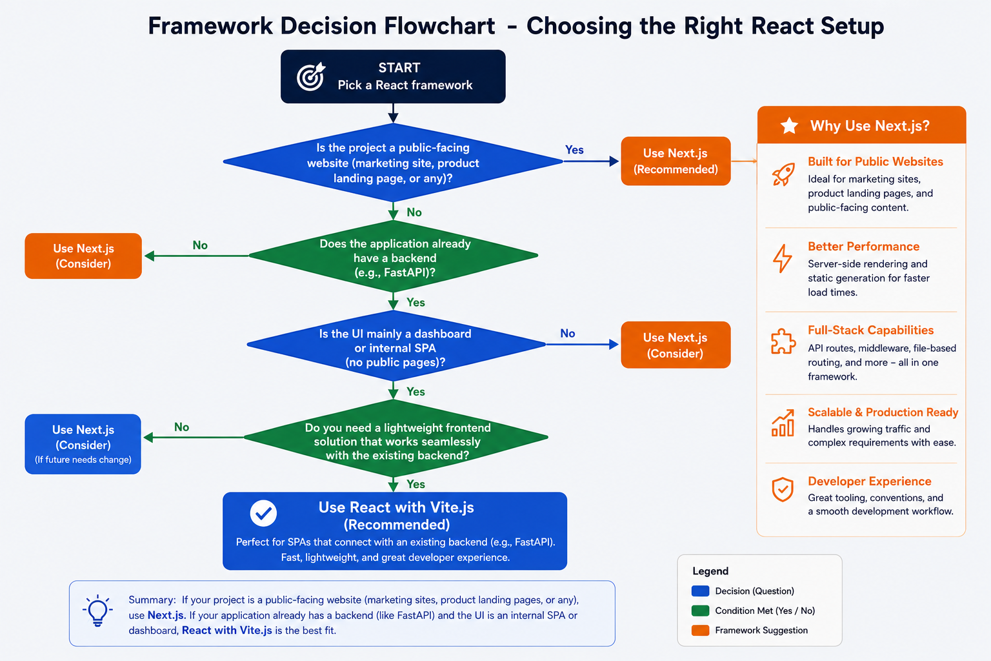
Figure - Decision flowchart: every branch relevant to our project leads to React + Vite
7) FAIRNESS - WHEN NEXT.JS WOULD BE THE BETTER CHOICE
This document does not argue that Next.js is a bad framework. To be transparent:
- Public-facing pages that require SEO (marketing sites, product landing pages)
- Apps where frontend and backend are in the same repo and the same team owns both
- Cases where server-side data fetching on every request is genuinely required

8) DECISION SUMMARY
A full comparison of both options against our project requirements:
Criteria | React + Vite | React + Next.js
Fits a pure SPA / dashboard | Yes - ideal fit | Overkill
Works cleanly with existing FastAPI | Yes - pure client | Yes, but server layer unused
Learning curve (backend dev, first FE) | Low - React only | High - SSR, hydration, directives
Dev server cold start | ~300 ms | 3 - 8 seconds
Hot Module Replacement | Near-instant | 1 - 3 seconds
Production build time | 5 - 15 seconds | 20 - 60 seconds
Deployment | Static build, anywhere | Needs Node server for SSR
Config complexity | Single vite.config.js | Multiple layers and conventions
Overall recommendation | Recommended | Not suited for this project

React + Vite is the smallest tool that fully solves the problem. It will help us focus on building dashboard correctly rather than navigating framework abstractions that do not contribute to project's goals.

